Project Planning Phase
Project Planning Template (Product Backlog, Sprint Planning, Stories, Story points)

Date | 18 February 2026
Team ID | 216
Project Name | Visualizing Housing Market Trends: An Analysis of Sale Prices and Features using Tableau
Maximum Marks

Product Backlog, Sprint Schedule, and Estimation (4 Marks)
Use the below template to create product backlog and sprint schedule

Sprint | Functional Requirement  (Epic) | User Story  Number | User Story / Task | Story Points | Priority | Team Members
Sprint-1 | Data Collection | USN-1 | As a user, I can upload housing data in CSV format | 3 | High | Utkarsh Sahu
Sprint-1 | Data Cleaning | USN-2 | As a developer, I can clean and preprocess housing data in Tableau | 5 | High | Utkarsh Sahu
Sprint-1 | Field Creation | USN-3 | As a user, I can create calculated fields like TotalAreaSqft | 2 | Medium | Utkarsh Sahu
Sprint-2 | Price Binning | USN-4 | As a user, I can create SalePriceBin for grouping houses | 2 | Medium | Vidisha Singh
Sprint-2 | Data Visualization | USN-5 | As a user, I can create sheets with charts: price vs features | 5 | High | Vidisha Singh
Sprint-2 | Dashboard Creation | USN-6 | As a user, I can build an interactive Tableau Dashboard with filters | 3 | High | Vidisha Singh
Sprint-2 | Dashboard Styling | USN-7 | As a user, I can style the dashboard for better  readability and navigation | 2 | Medium | Vidisha Singh
Sprint-1 | Flask Integration | USN-8 | As a developer, I can embed Tableau dashboard into a Flask web app | 5 | High | Utkarsh Sahu
Sprint-1 | Embed Testing | USN-9 | As a user, I can test and review the embedded dashboard UI | 2 | Medium | Utkarsh Sahu
Sprint-1 | Documentation | USN-10 | As a team, we can prepare final project documentation | 3 | High | Utkarsh Sahu

Project Tracker, Velocity & Burndown Chart: (4 Marks)

Sprint | Total Story Points | Duration | Sprint Start Date | Sprint End Date (Planned) | Story Points Completed (as on  Planned End Date) | Sprint Release Date (Actual)
Sprint-1 | 10 | 5 Days | 18 February 2026 | 23 February 2026 | 10 | 24 February 2026
Sprint-2 | 10 | 5 Days | 18 February 2026 | 23 February 2026 | 10 | 22 February 2026

Velocity:
Imagine we have a 10-day sprint duration, and the velocity of the team is 20 (points per sprint). Let’s calculate the team’s average velocity (AV) per iteration unit (story points per day)

AV =32/10≈3.2 story points/day

Burndown Chart:

A burn down chart is a graphical representation of work left to do versus time. It is often used in agile software development methodologies such as Scrum. However, burn down charts can be applied to any project containing measurable progress over time.

Burndown Chart for All Sprints
Remaining Story Points
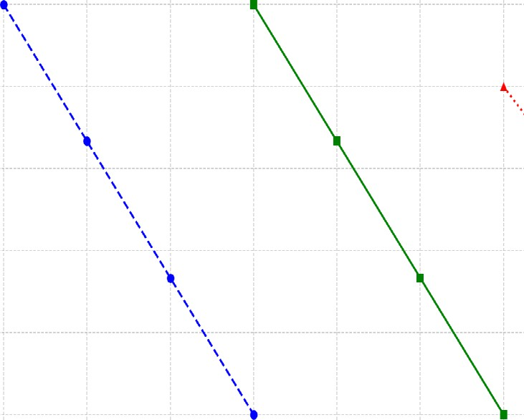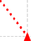
10
-•- Sprint 1
- Sprint 2
Sprint 3
8
6
0

0 4
Days
6 7 8 9

